Name: Arnav Adarsh
Roll Number: 2305199
Batch/Program: B.Tech Computer Science (3rd Year) -2027
LabFlow Analytics: Automated Clinical Test Pipeline & Anomaly Detection System
1. Problem Statement
Modern healthcare facilities and diagnostic centers generate immense volumes of clinical lab data daily. Historically, the processing, cleaning, and analysis of this medical data have been manual or semi-manual. This traditional approach leads to delayed reporting, increased human error, and severe scalability bottlenecks when dealing with millions of records.
Furthermore, identifying critical patient anomalies—such as life-threatening blood sugar spikes, abnormal cholesterol levels, or out-of-range HbA1c metrics—buried within millions of historical records is a significant challenge. Without an automated system, data sits in silos, making it nearly impossible for healthcare professionals to track rolling averages or spot immediate health risks in real-time. There is a critical industry need for a highly scalable, automated data engineering pipeline capable of ingesting raw medical data, standardizing it into a central warehouse, and immediately flagging abnormal results to ensure timely medical intervention and efficient hospital data management.
2. Solution and Key Features
To solve the challenges of healthcare data management, this project implements a fully automated, end-to-end data engineering pipeline. It simulates a real-world healthcare data system where massive datasets are generated, processed, stored, analyzed, and finally visualized for decision-making without manual intervention.
The pipeline processes approximately 1.4 million records and is broken down into four core engineering phases:
Phase 1: Data Ingestion & Simulation
The pipeline begins by handling raw, unstructured CSV data. A structured Linux file system was engineered to isolate configuration files, scripts, logs, and raw data. A custom bash shell script (ingest_data.sh) was deployed to automate the movement of synthetic lab data from a 'landing' directory to a 'processing' directory. This ensures that raw files are safely captured and staged for transformation while maintaining robust execution logs for system audits.
Phase 2: Data Modelling & Storage
Raw data often contains missing values and inconsistent formatting. A Python-based cleaner script normalizes the data before it enters the warehouse. To ensure high-performance querying, a Star Schema architecture was designed in MySQL.
- Fact Table: fact_lab_results was created to store measurable test values, timestamps, and anomaly flags.
- Dimension Tables: dim_patient, dim_test, and dim_hospital were built to store descriptive metadata. An ETL (Extract, Transform, Load) batch-processing script was implemented to safely load the 1.4 million records into the database. Composite join conditions were utilized to prevent data duplication, and database indexing was applied to drastically improve query retrieval times.
Phase 3: Big Data Processing
To handle analytics at a massive scale, the pipeline leverages Apache Spark (PySpark). Distributed processing was utilized to bypass the memory limits of standard Python execution. Advanced SQL Window Functions were applied across the Spark DataFrames to calculate the rolling 30-day average for every patient's test results. Finally, to optimize long-term storage and reduce query latency, the processed DataFrame was converted into the Parquet format and partitioned by collection_date.
Phase 4: Orchestration & Dashboard Visualization
To eliminate the need for manual script execution, the entire architecture is orchestrated using Apache Airflow. A Directed Acyclic Graph (DAG) named lab_test_pipeline strictly enforces task dependencies (Data Generation → Cleaning → Warehouse Loading → Spark Analytics → Anomaly Detection). Additionally, a real-time Streamlit analytics dashboard was developed to visualize the output. It features KPI tracking, anomaly highlighting, and interactive time-series plots, bridging the gap between backend data engineering and frontend business intelligence.
3. Project Architecture and Data Flow
The architecture follows a strict, fault-tolerant sequence:
- Data Generation: Python simulates incoming lab machine records.
- Ingestion: Shell script securely moves data to the processing layer.
- Transformation: Python (Pandas) cleans missing values and standardizes units.
- Staging & Storage: MySQL houses the Star Schema warehouse.
- Big Data Analytics: PySpark computes rolling averages in a distributed manner.
- Data Lake Storage: Results are saved as partitioned Parquet files.
- Quarantine: Anomaly detection isolates critical patient records.
- Orchestration: Airflow governs the entire flow automatically.
- Visualization: Streamlit + Plotly render interactive insights.
4. Screenshots of Implementation
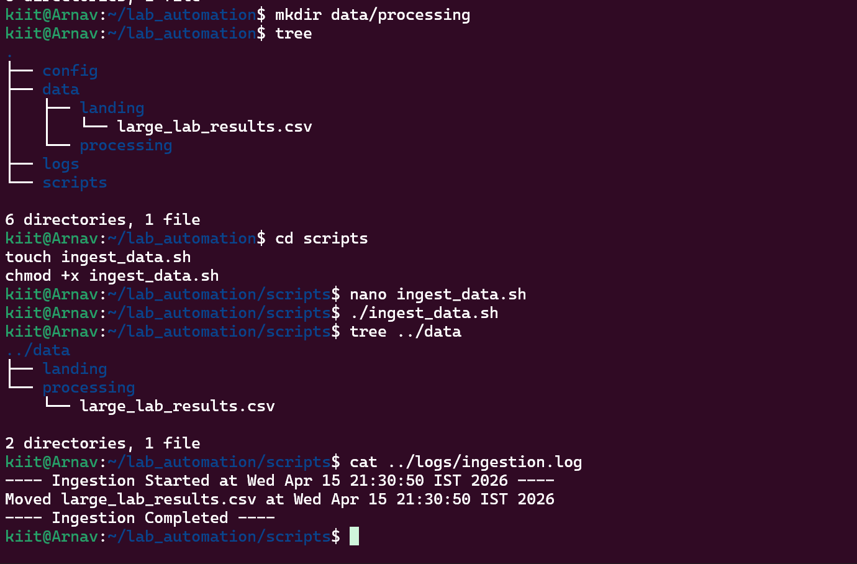 Phase 1 - Structured Linux directory and automated ingestion shell script execution.
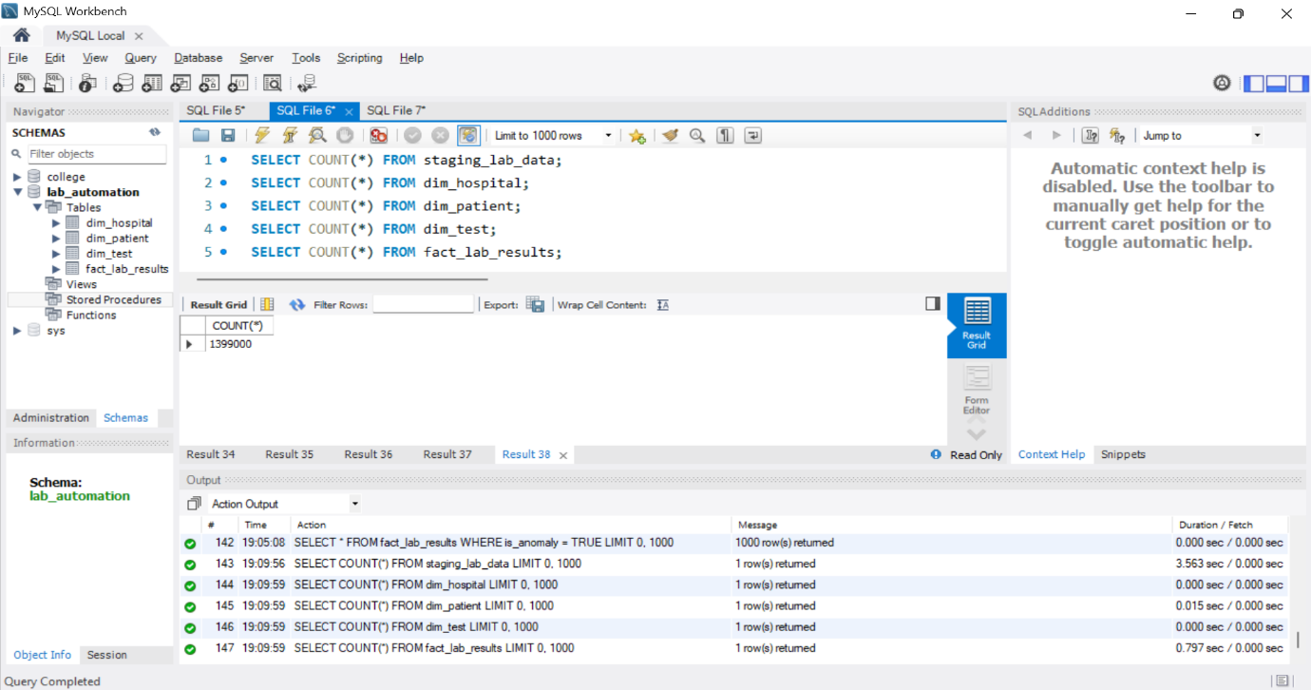Phase 2 - Execution of ETL batch processing and successful loading of 1.4 million rows into the Star Schema.
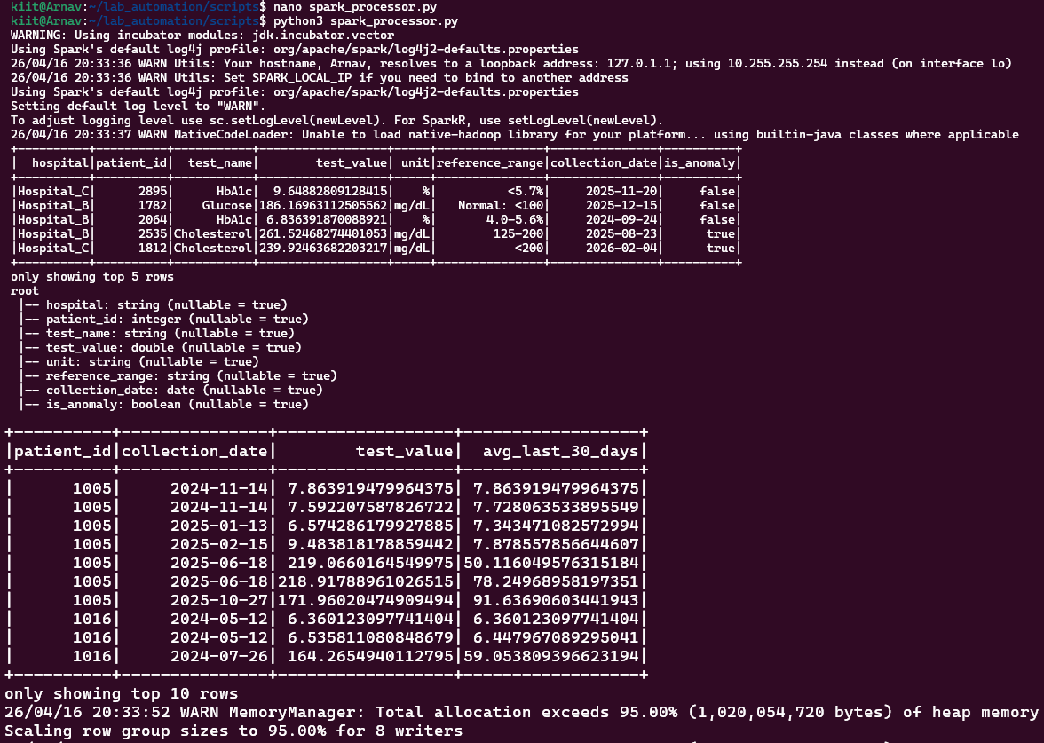Phase 3 - PySpark distributed processing utilizing window functions to calculate patient rolling averages.
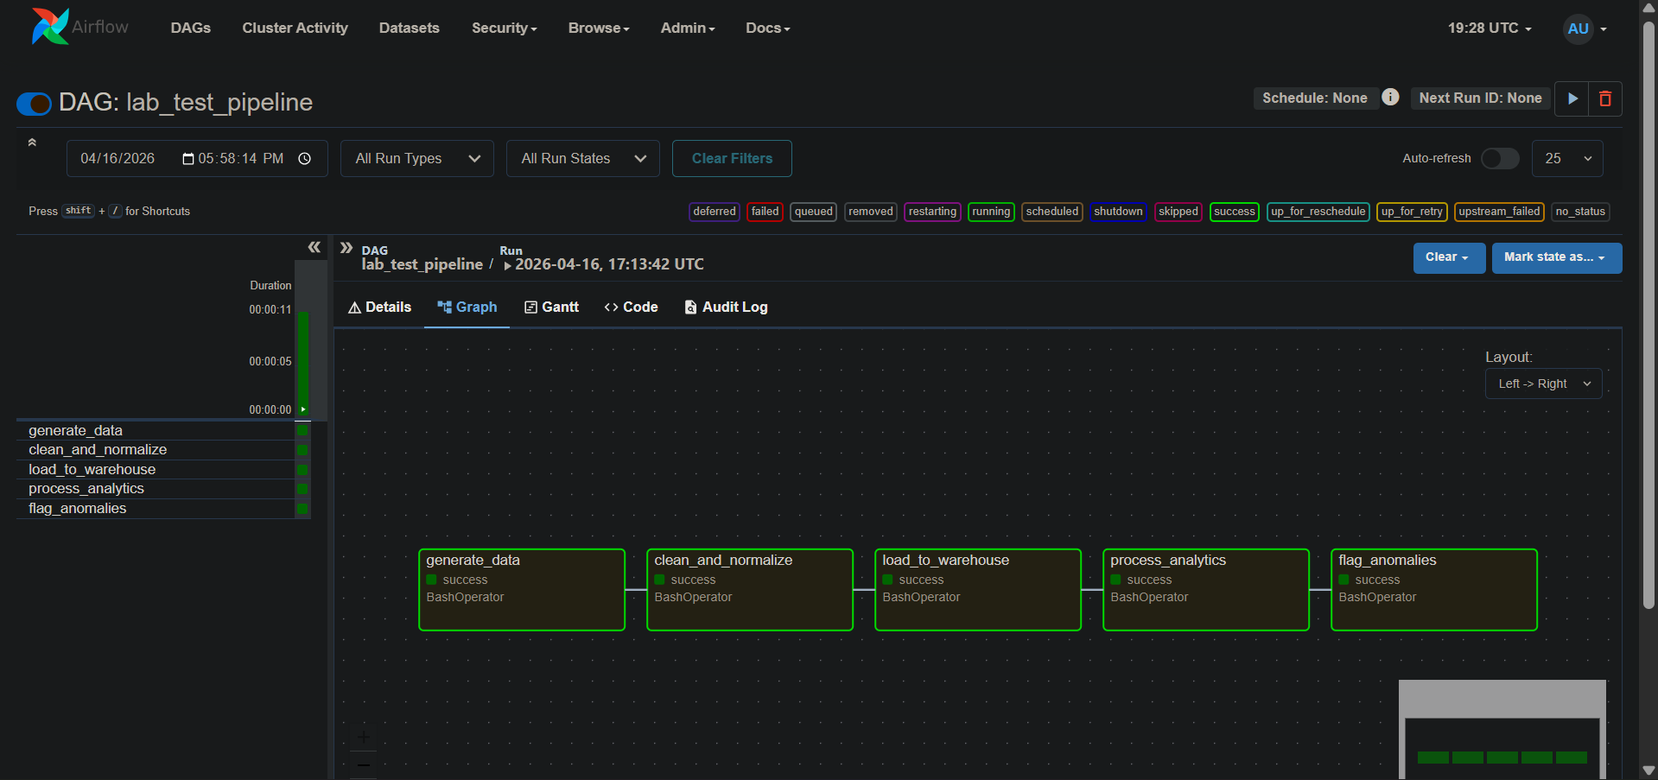Phase 4 - Apache Airflow UI showing the successful, automated execution of the entire end-to-end DAG pipeline.
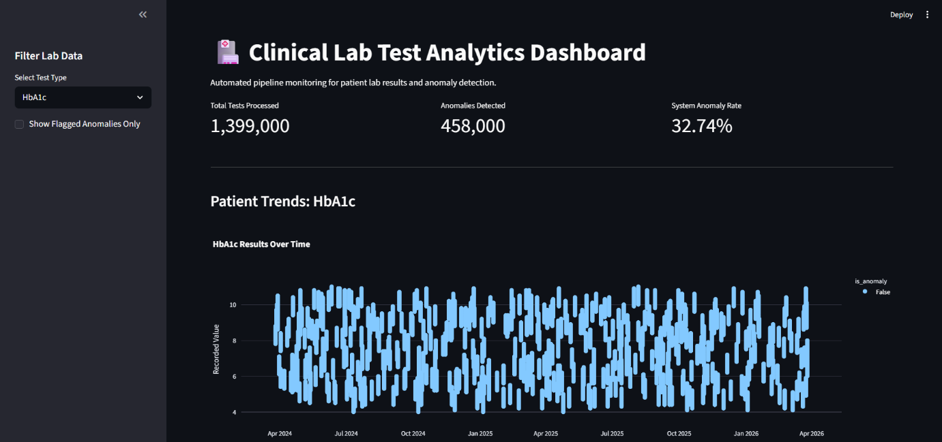 Phase 5 - Interactive Streamlit dashboard visualizing patient lab trends and flagging medical anomalies.
5. Technology Stack
- Operating System & Scripting: Linux, Bash Shell Scripting (for automated file routing and permission management).
- Programming Languages: Python 3 (Core pipeline logic, data cleaning, and scripting).
- Data Manipulation: Pandas (in-memory data cleaning) and PySpark (distributed big data analytics and window functions).
- Database & Storage: MySQL (Star Schema Data Warehouse) and Apache Parquet (optimized, partitioned Data Lake storage).
- Workflow Orchestration: Apache Airflow (DAG management, task dependency, and scheduling).
- Data Visualization: Streamlit and Plotly (interactive web dashboards and UI rendering).
6. Unique Points of the Project
- Fully Orchestrated End-to-End Automation: Unlike standard isolated scripts, the entire pipeline is governed by an Apache Airflow DAG. This allows for zero-touch execution from raw data ingestion to final analytics processing.
- Big Data Optimization via Spark & Parquet: The architecture natively handles a massive dataset of ~1.4 million records. By utilizing PySpark for distributed processing and converting the output to Parquet format partitioned by date, the system drastically reduces its storage footprint and accelerates query times compared to traditional databases.
- Intelligent Data Quality & Quarantine: The pipeline features a built-in anomaly detection module. Instead of discarding bad data, it isolates critical medical anomalies (e.g., out-of-bounds glucose levels) into a separate "quarantine" CSV file for immediate manual review by healthcare professionals.
- Actionable Frontend Integration: The backend engineering effort is seamlessly visualized through an interactive Streamlit dashboard, proving that the pipeline delivers tangible, accessible business intelligence.
7. Future Improvements
- Cloud Infrastructure Migration: Transitioning the local Linux-based storage and MySQL staging environment to cloud-native solutions. Future iterations could utilize AWS S3 for the raw data lake and Amazon Redshift or Google BigQuery for the enterprise data warehouse.
- Real-Time Data Streaming: Upgrading the current batch-processing architecture to a real-time streaming model. By integrating Apache Kafka, the pipeline could ingest, process, and flag abnormal lab results the exact second they are transmitted from hospital testing equipment.
- Predictive Machine Learning Integration: Leveraging the structured historical data and PySpark's MLlib to train predictive models. This would allow the system to forecast patient health trends (e.g., predicting the likelihood of critical HbA1c levels in the next quarter) rather than just reporting historical anomalies.
8. Conclusion
The AetherData Lab Analytics project successfully demonstrates a production-grade data engineering workflow. By integrating Linux automation, relational data warehousing, distributed PySpark analytics, and Airflow orchestration, the pipeline efficiently transforms over a million rows of raw healthcare data into actionable, visualized insights. It ensures data scalability, enforces strict data quality validation, and provides a reliable framework for modern clinical data management.

